Lab 5 202283910012 张景橦

1. **What is a container**

Search

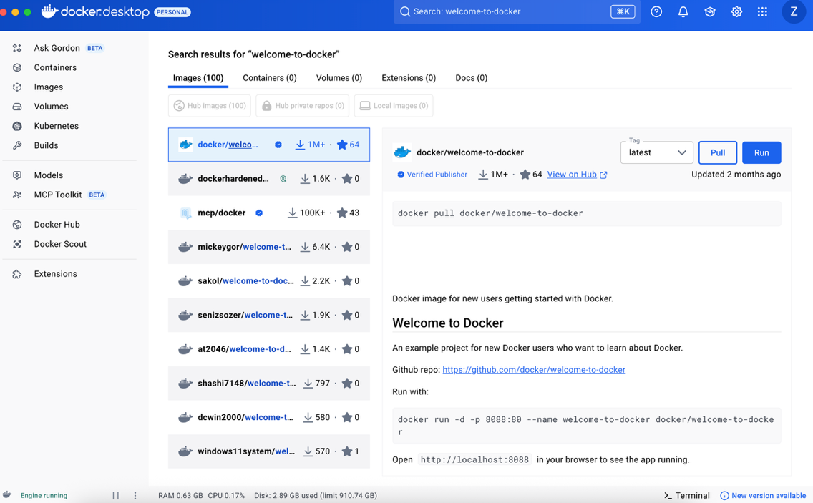

Run

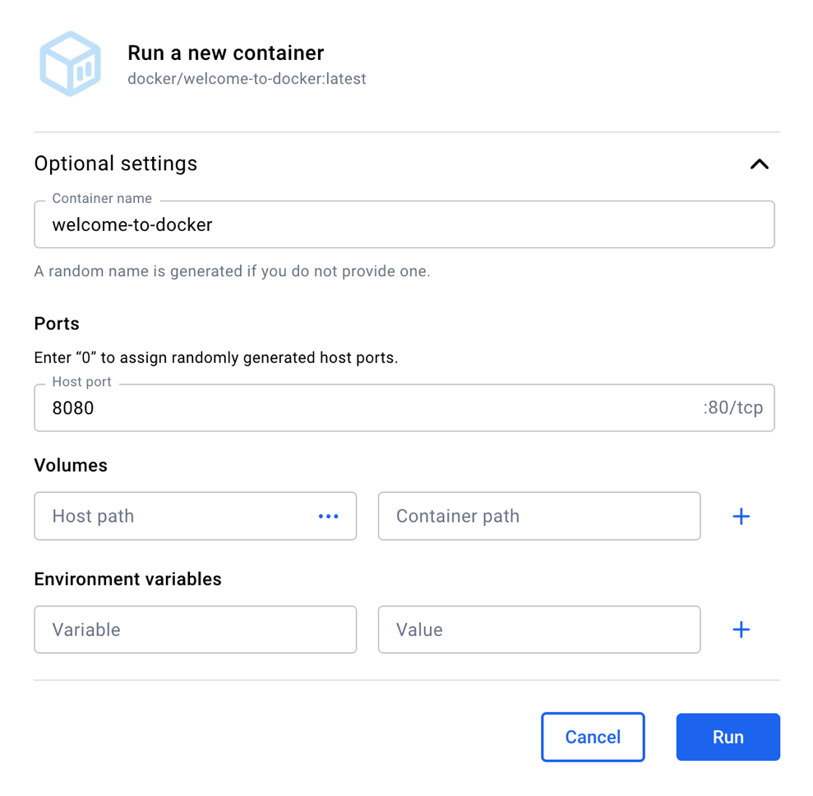

View

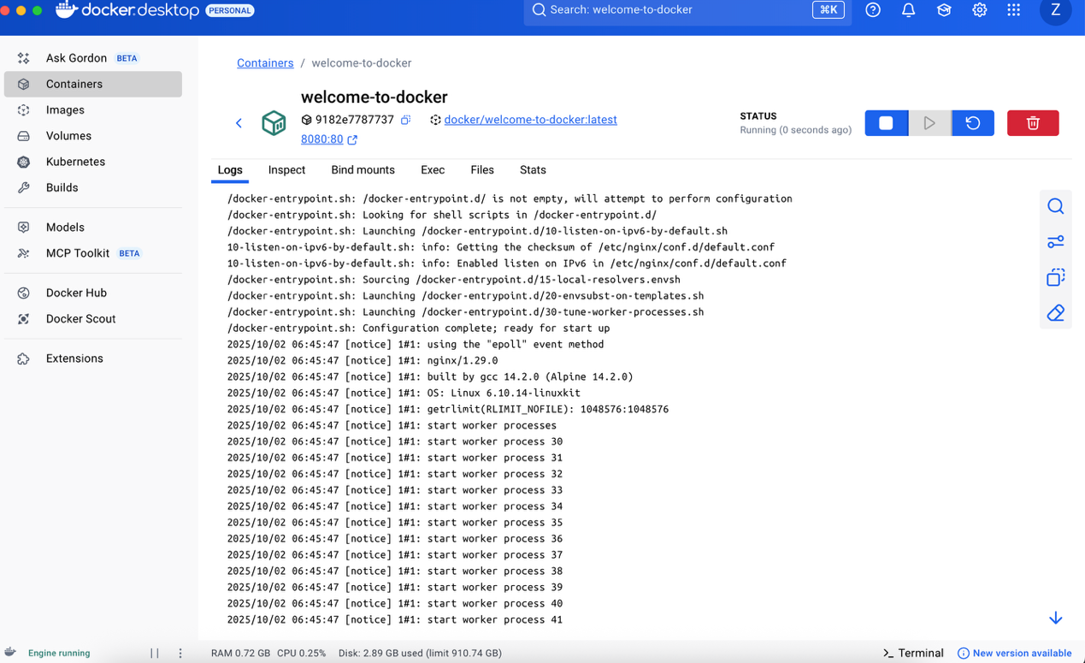

Visit http://localhost:8080

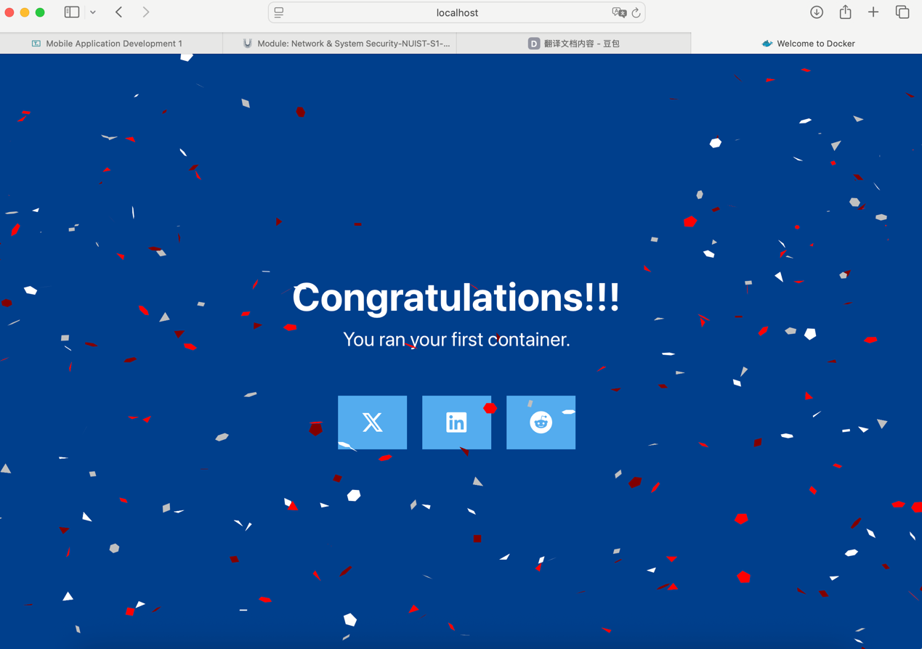

Explore

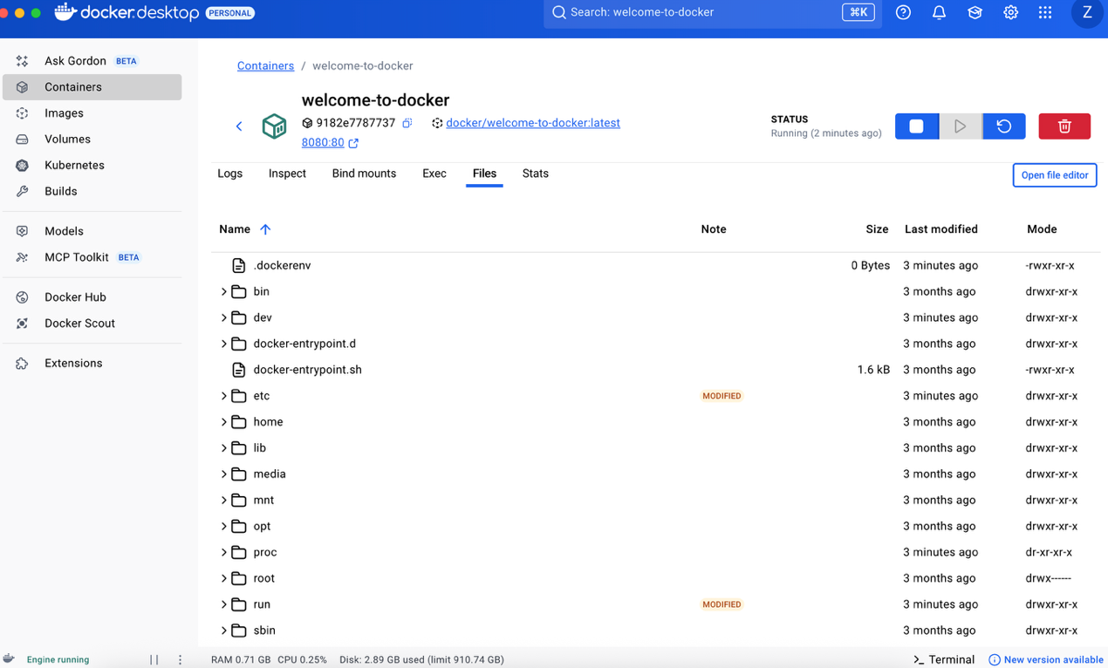

Stop

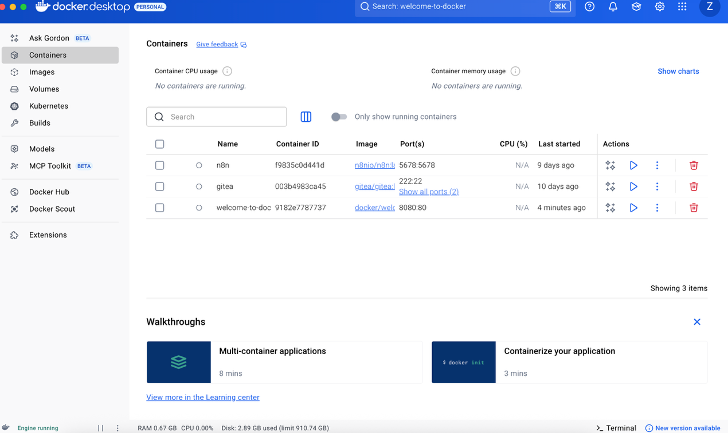

1. **What is an image**

Image page

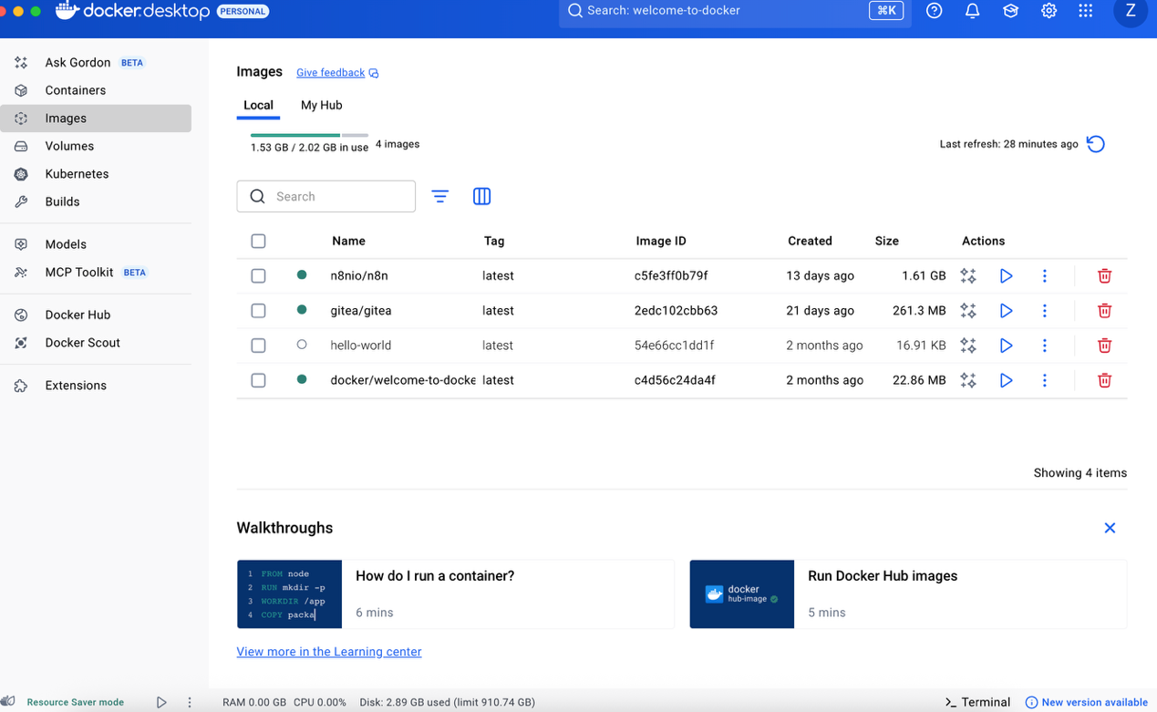

Image details

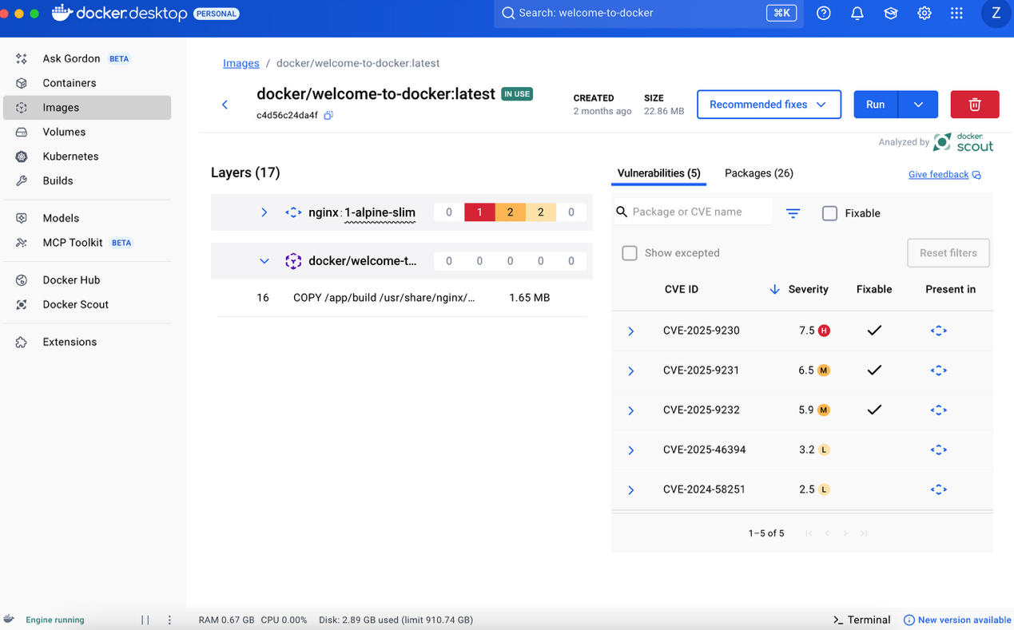

1. **What is a docker compose**

Clone the sample application and navigate into the todo-list-app

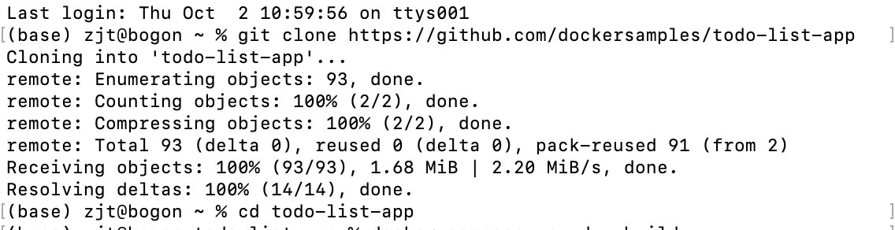

Use the docker compose up command to start the application

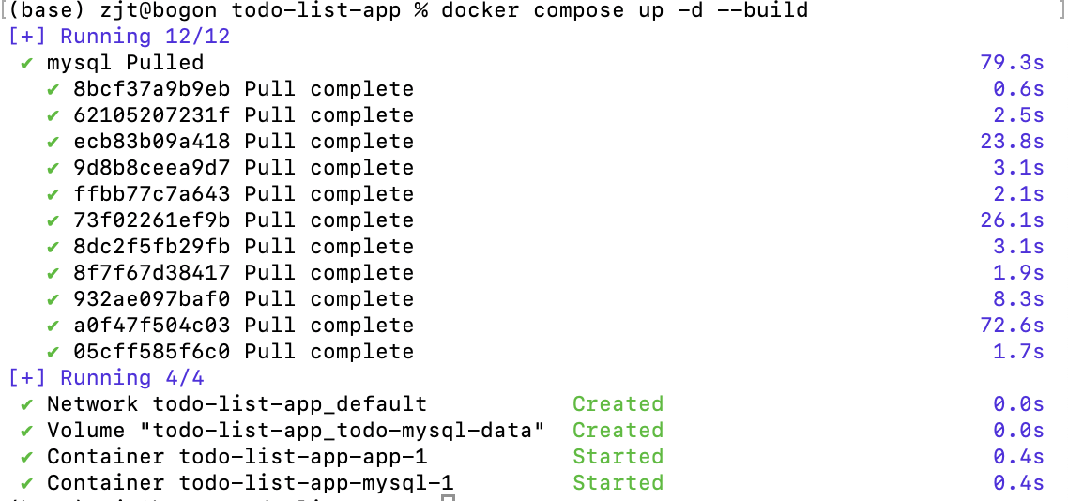

Open <http://localhost:3000>

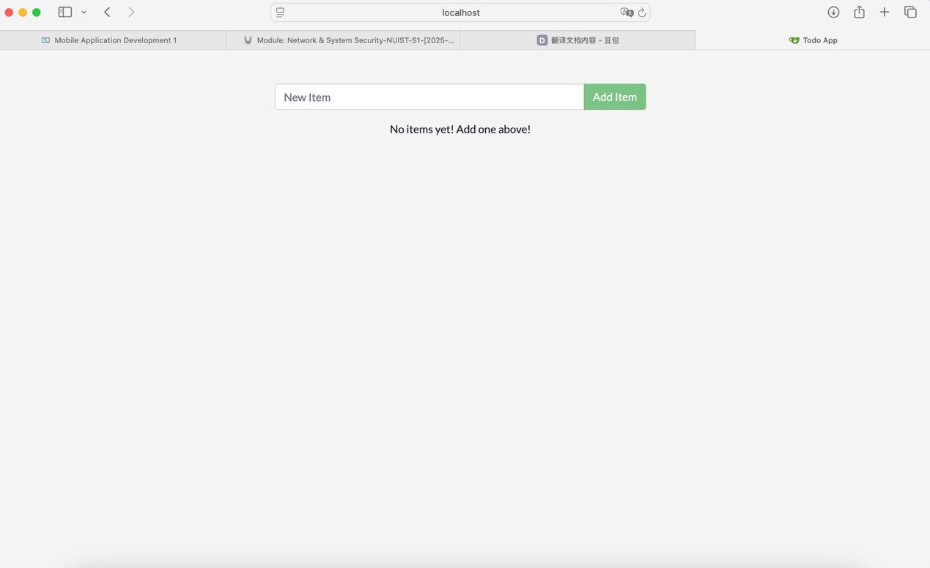

Docker Desktop GUI

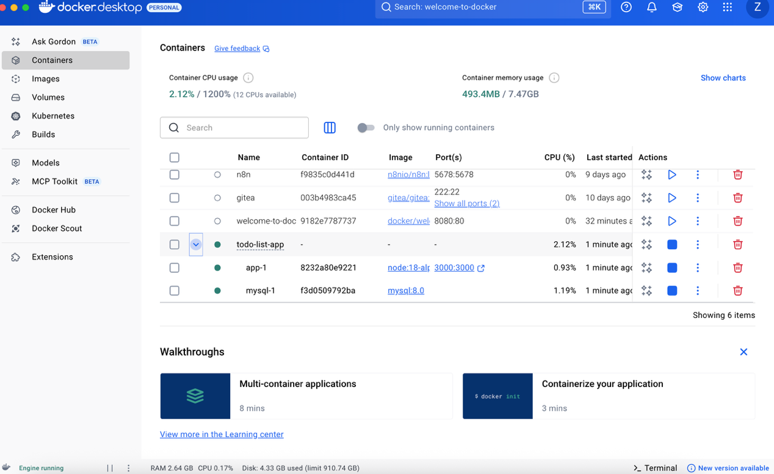

Tear it down

图片包含 散点图

AI 生成的内容可能不正确。

1. **Publishing and exposing ports**

Publishing ports

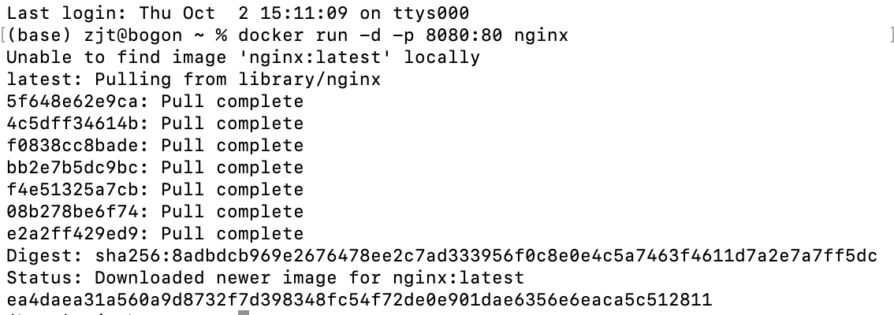

Publishing to ephemeral ports

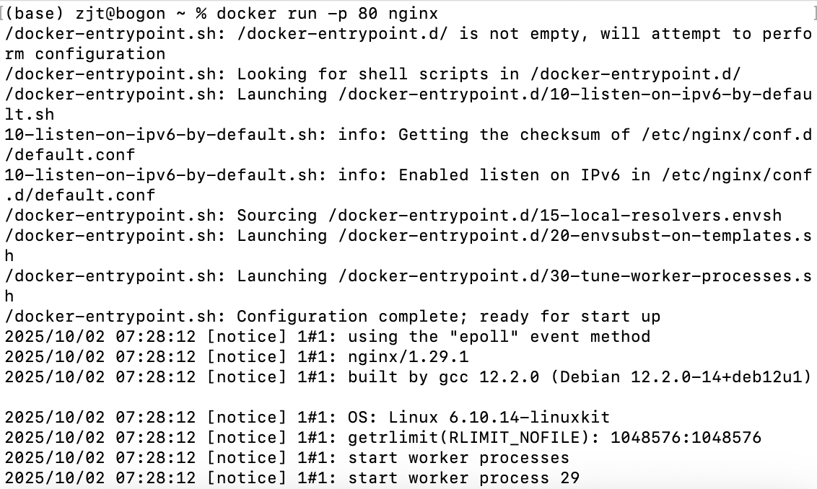

Once the container is running, using docker ps will show you the port that was chosen:

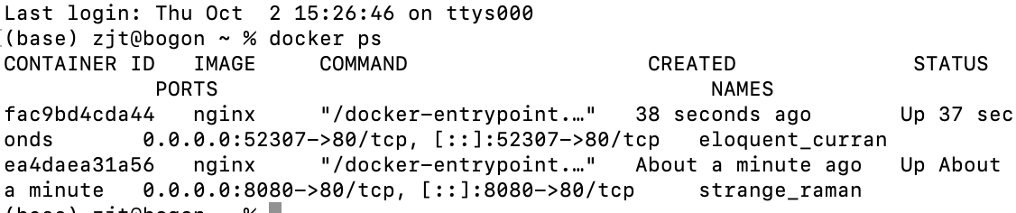

Publishing all ports:

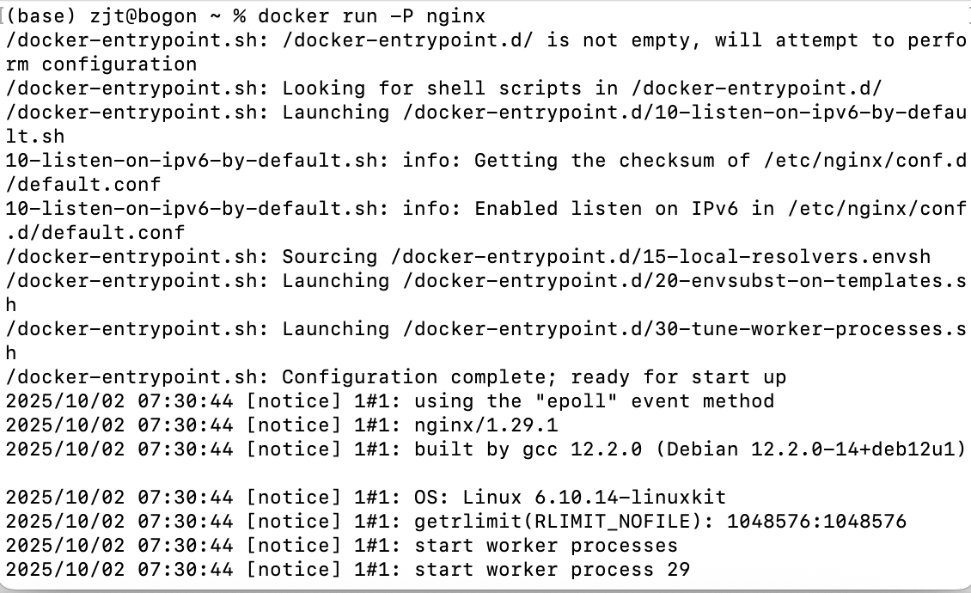

Start a new container: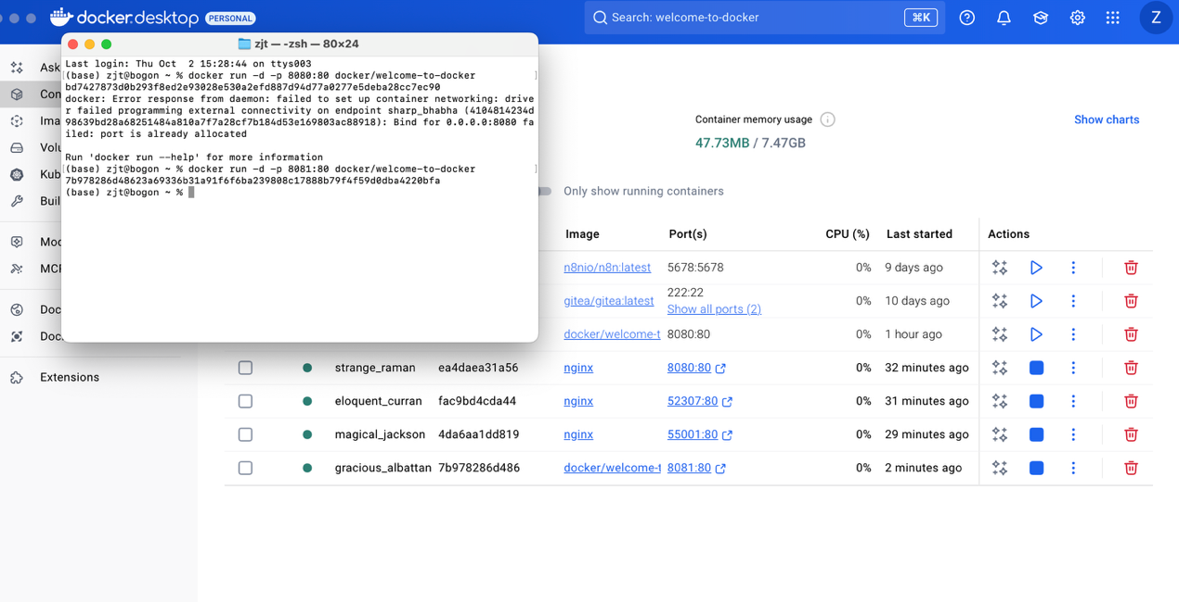

Use Docker Compose

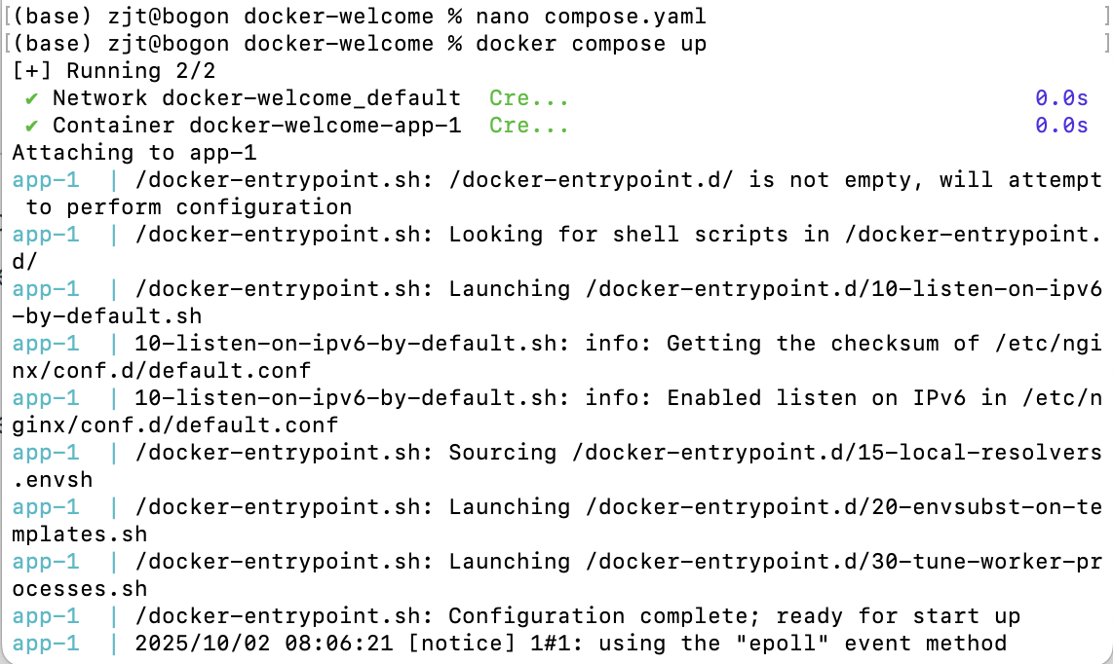

1. **Overriding container defaults**

Run multiple instances of the Postgres database

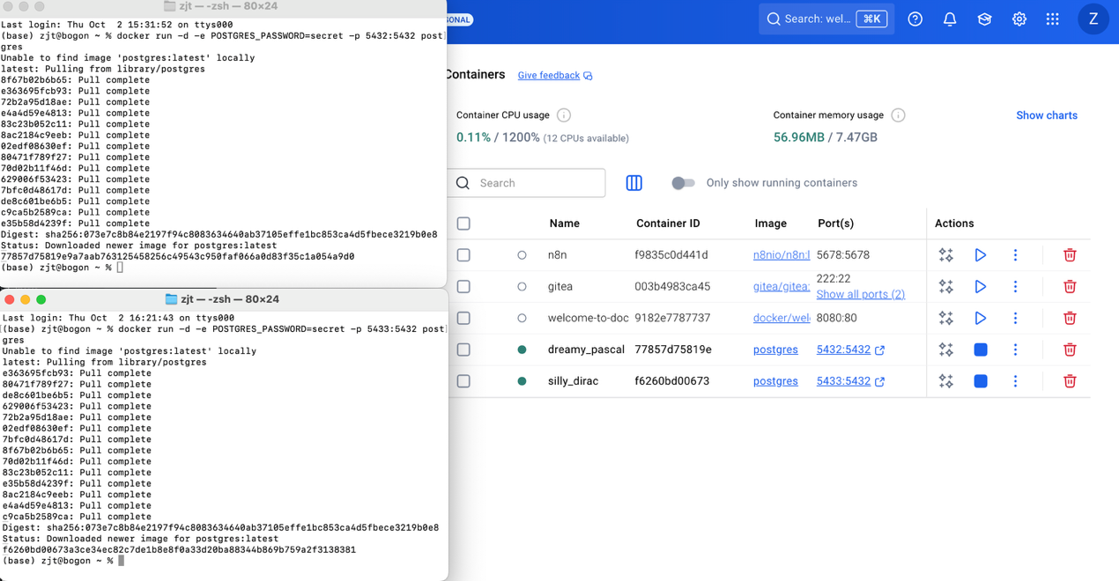

Run Postgres container in a controlled network

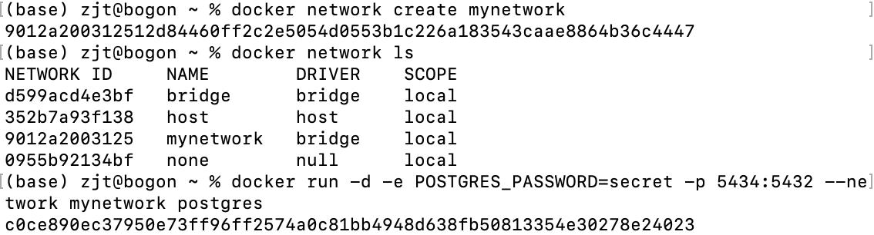

Manage the resources

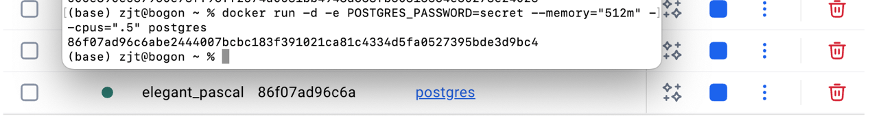

Override the default CMD and ENTRYPOINT in Docker Compose

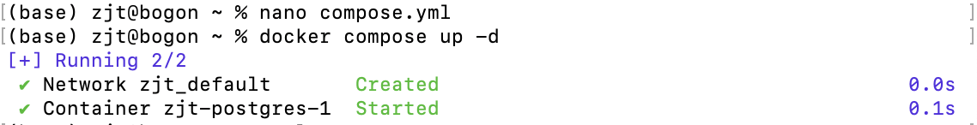

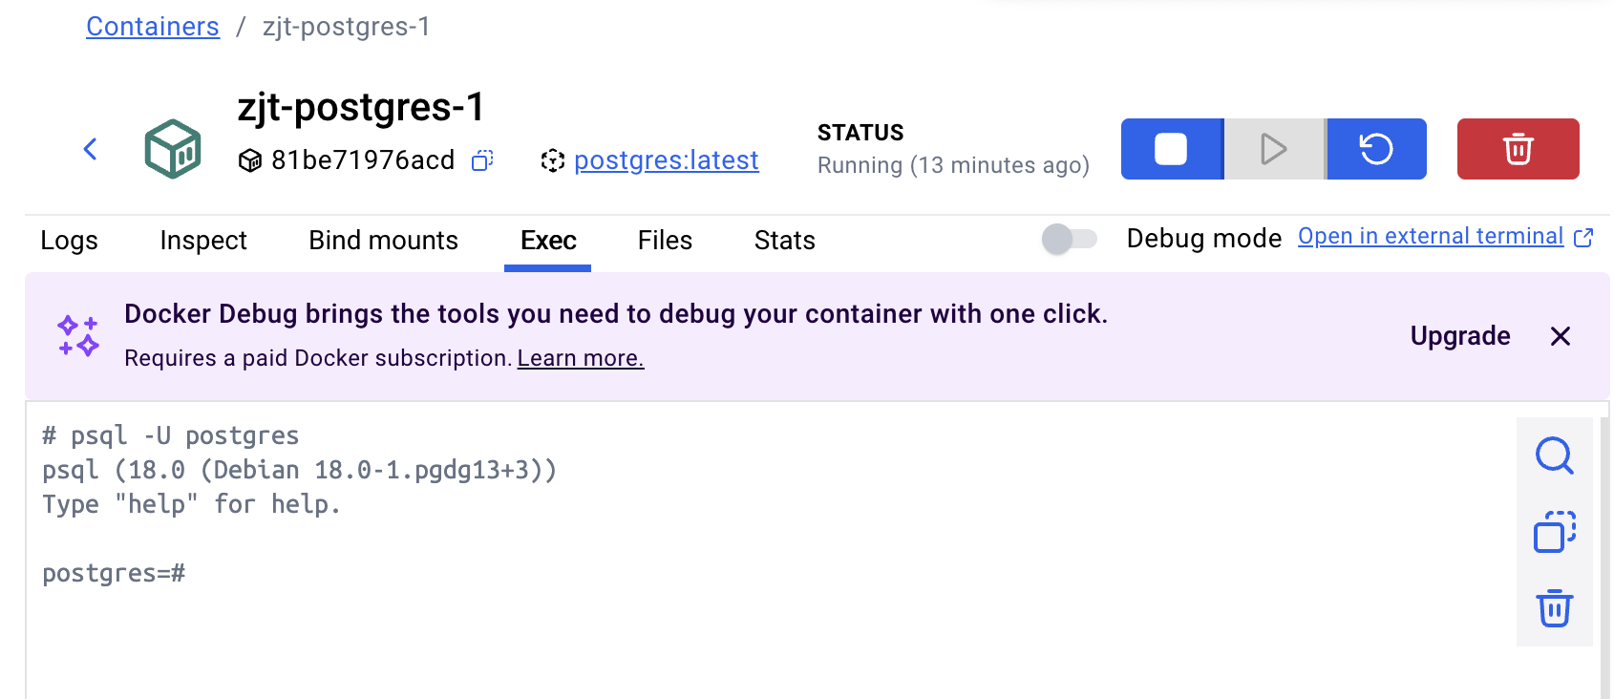

Override the default CMD and ENTRYPOINT with docker run

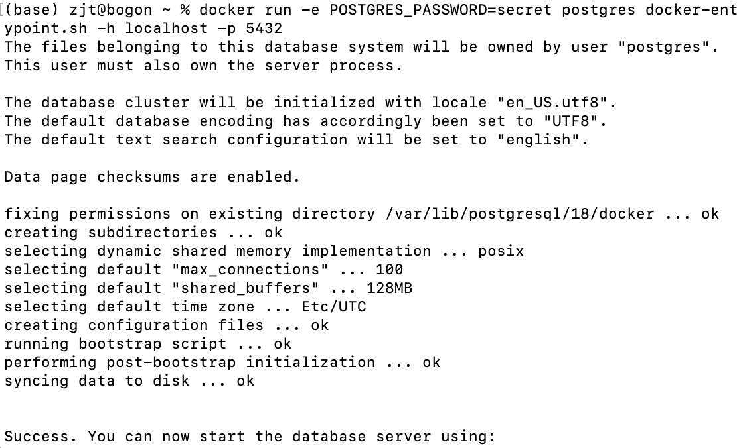

1. **Persisting container data**

Use volumes

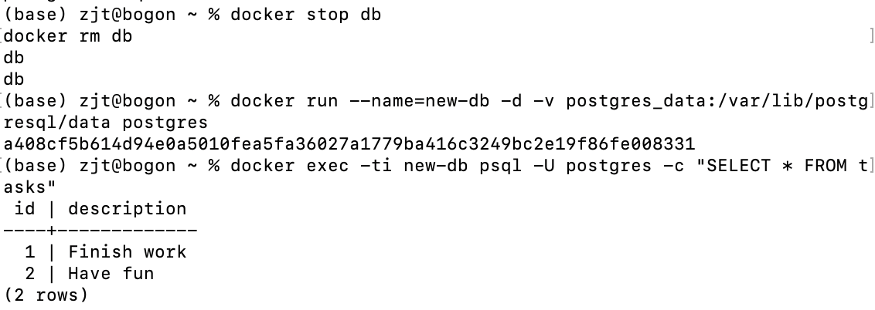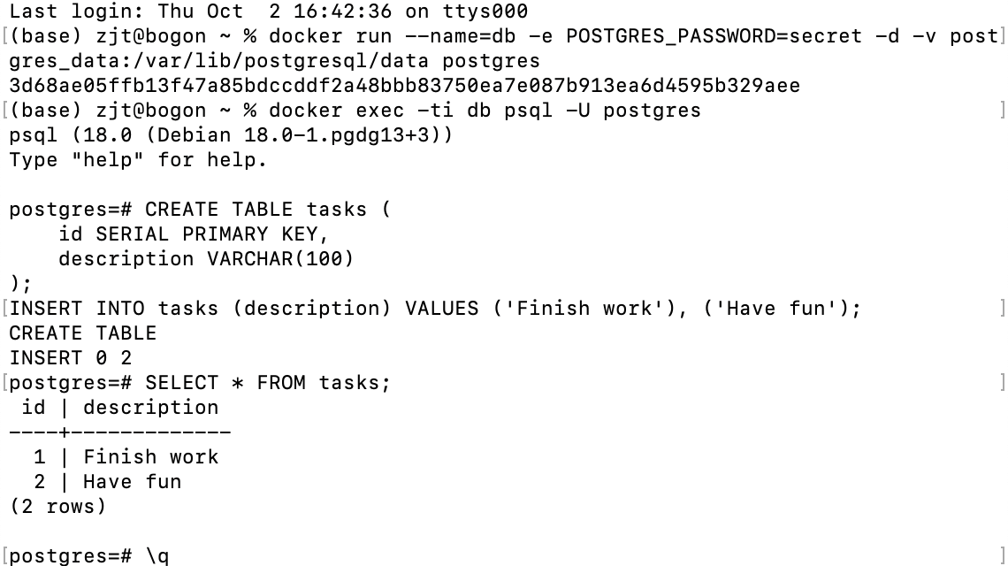

Remove volumes

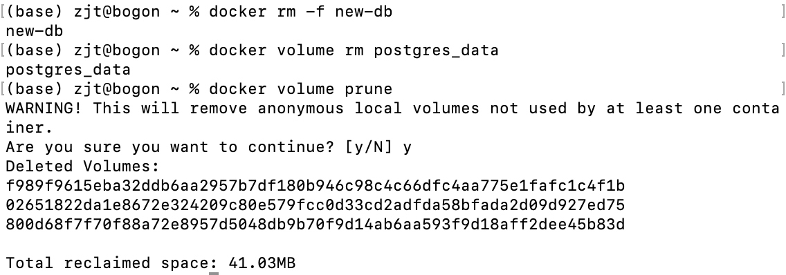

1. **Sharing local files with containers**

Run a container

文本, 信件

AI 生成的内容可能不正确。

Use a bind mount

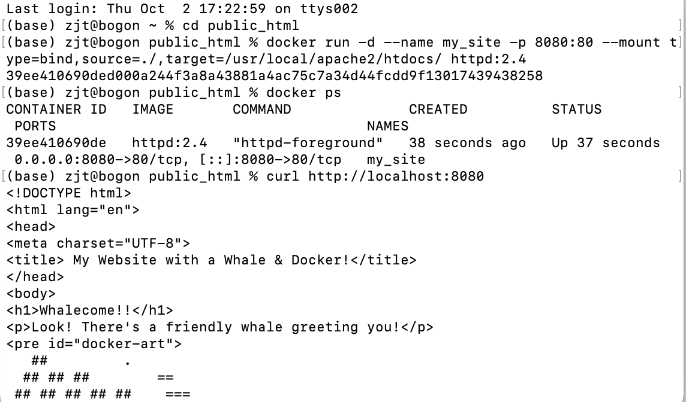图形用户界面, 文本, 应用程序

AI 生成的内容可能不正确。

Access the file on the Docker Desktop Dashboard

图形用户界面, 应用程序

AI 生成的内容可能不正确。

1. **Multi-container applications**

Build the images

图片包含 文本

AI 生成的内容可能不正确。

Run the containers

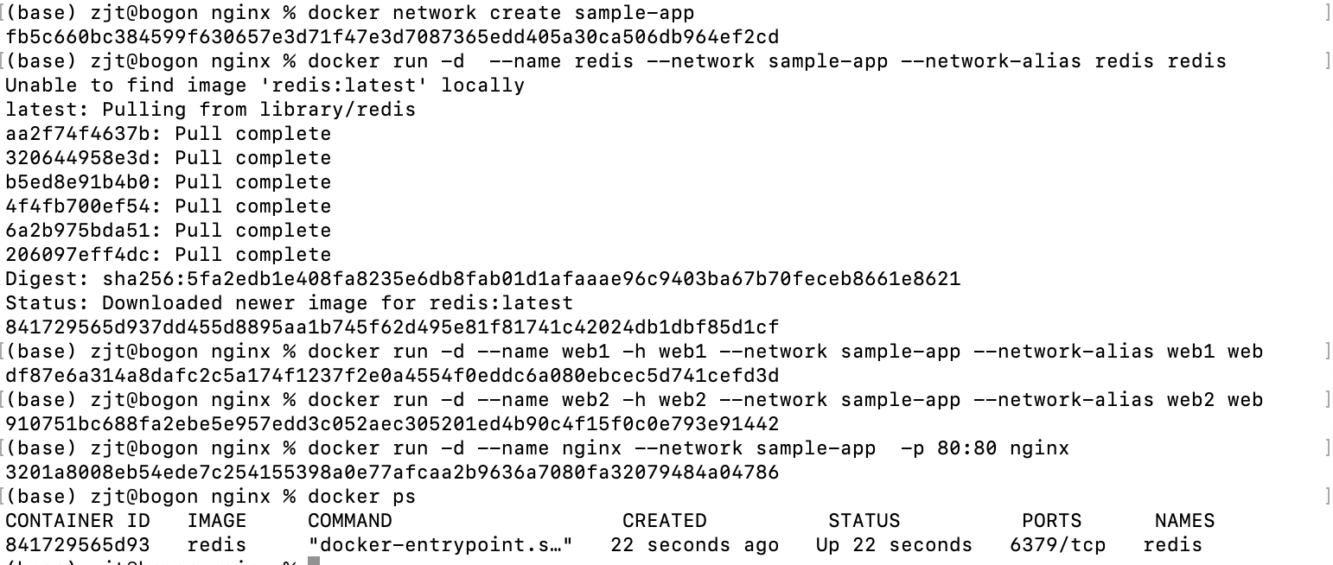

图形用户界面, 应用程序

AI 生成的内容可能不正确。